Tutorial – 8.2

**Aim:** write a program using 'awk' function, which convert each word in a given text into capital word.

**Code:**#!/bin/bash

echo "Enter a text:"

read text

uppercase_text=$(echo "$text" | awk '{for(i=1;i<=NF;i++) $i=toupper($i)}1')

echo "Text with each word converted to uppercase:"

echo "$uppercase_text"

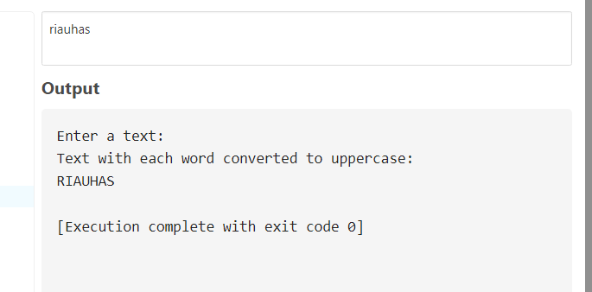**Output:**